**Convolutional Neural Networks for Image Classification**

<https://missinglink.ai/guides/convolutional-neural-networks/convolutional-neural-networks-image-classification/>

Image classification algorithms, powered by Deep Learning (DL) [Convolutional Neural Networks  (CNN)](https://missinglink.ai/guides/neural-network-concepts/convolutional-neural-network-architecture-forging-pathways-future/), fuel many advanced technologies and are a core research subject for many industries ranging from transportation to healthcare.

## WHAT IS IMAGE CLASSIFICATION?

Image classification is the process of labeling images according to predefined categories. The process of image classification is based on supervised learning. An image classification model is fed a set of images within a specific category. Based on this set, the algorithm learns which class the test images belong to, and can then predict the correct class of future image inputs, and can even measure how accurate the predictions are.

This process introduces multiple challenges, including scale variation, viewpoint variation, intra-class variation, image deformation, image occlusion, illumination conditions and background clutter.

For example, if “dog” is one of the predefined categories, the image classification algorithm will recognize the image below is one of a dog and label it as such.

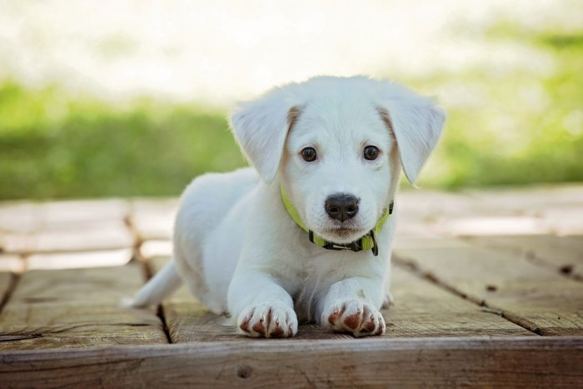

**An image classification network will recognize that this is a dog**

## DEEP LEARNING FOR IMAGE CLASSIFICATION

Deep learning, a subset of Artificial Intelligence (AI), uses large datasets to recognize patterns within input images and produce meaningful classes with which to label the images. A common deep learning method for image classification is to train an [Artificial Neural Network (ANN)](https://missinglink.ai/guides/neural-network-concepts/complete-guide-artificial-neural-networks/) to process input images and generate an output with a class for the image.

The challenge with deep learning for image classification is that it can take a long time to train artificial neural networks for this task. However, Convolutional Neural Networks (CNNs) excel at this type of task.

### THE USE OF CONVOLUTIONAL NEURAL NETWORKS FOR IMAGE CLASSIFICATION

The CNN approach is based on the idea that the model function properly based on a local understanding of the image. It uses fewer parameters compared to a fully connected network by reusing the same parameter numerous times. While a fully connected network generates weights from each pixel on the image, a convolutional neural network generates just enough weights to scan a small area of the image at any given time.

This approach is beneficial for the training process━the fewer parameters within the network, the better it performs. Additionally, since the model requires less amount of data, it is also able to train faster.

When a CNN model is trained to classify an image, it searches for the features at their base level. For example, while a human might identify an elephant by its large ears or trunk, a computer will scan for curvatures of the boundaries of these features. Some object detection networks like [YOLO](https://missinglink.ai/guides/neural-network-concepts/yolo-deep-learning-dont-think-twice/) achieve this by generating bounding boxes, which predict the presence and class of objects within the bounding boxes. [Instance segmentation](https://missinglink.ai/guides/neural-network-concepts/instance-segmentation-deep-learning/) , a subset of [image segmentation](https://missinglink.ai/guides/neural-network-concepts/image-segmentation-deep-learning-methods-applications/) , takes this a step further and draws boundaries for each object, identifying its shape.

There are many applications for image classification with deep neural networks. CNNs can be embedded in the systems of autonomous cars to help the system recognize the surrounding of the car and classify objects to distinguish between ones that do not require any action, such as trees on the side of the road, and ones that do, such as civilians crossing the street.

Another use for CNNs is in advertising. For example, CNNs can easily scan a person’s Facebook page, classify fashion-related images and detect the person’s preferred style, allowing marketers to offer more relevant clothing advertisements. With a deep enough network, this principle can also be applied to identifying locations, such as pubs or malls, and hobbies like football or dancing.

## ImageNet CLASSIFICATION WITH DEEP CONVOLUTIONAL NEURAL NETWORKS

This ImageNet challenge is hosted by the ImageNet project, a visual database used for researching computer image recognition. The project’s database consists of over 14 million images designed for training convolutional neural networks in image classification and object detection tasks.

### POPULAR ARCHITECTURES FOR IMAGE CLASSIFICATION

The ImageNet classification challenged has introduced many popular convolutional neural networks since it was established, which are now widely used in the industry. This is highly important in AI for image recognition, given that the ability to optimize a CNN architecture has a big effect on its performance and efficiency.